“HARVEST HUB”

(A HELPER OF FARMERS)

A Project report submitted in

partial fulfilment of the requirements

for the Degree of

**Bachelor of Technology**

in

**Computer Engineering**

Submitted by

**Nikam Prachi Sitaram**

**Patil Chetana Motilal**

**Patil Kamini Sharad**

**Bhamare Mayuri Dipak**



**DEPARTMENT OF COMPUTER ENGINEERING**

S.S.V.P.S.’s B.S. DEORE COLLEGE OF ENGINEERING, DHULE

2023-24

“HARVEST HUB”

(A helper of farmers)

A Project report submitted

in partial fulfilment of the requirements

for the Degree of

**Bachelor of Technology**

In

**Computer Engineering**

Submitted by

**Nikam Prachi Sitaram**

**Patil Chetana Motilal**

**Patil Kamini Sharad**

**Bhamare Mayuri Dipak**

Guided by

**Mrs. B.D.Patil**



**DEPARTMENT OF COMPUTER ENGINEERING**

S.S.V.P.S.’s B.S. DEORE COLLEGE OF ENGINEERING, DHULE

2023-24

**S.S.V.P.S.’s B.S. DEORE COLLEGE OF ENGINEERING, DHULE**

**DEPARTMENT OF COMPUTER ENGINEERING**

# **CERTIFICATE**

This is to certify that the Project entitled “HARVEST HUB*”* has been carried out by

**Nikam Prachi Sitaram**

**Patil Chetana Motilal**

**Patil Kamini Sharad**

**Bhamare Mayuri Dipak**

under my guidance in partial fulfilment of the degree of *Bachelor of Technology* in *Computer Engineering* of Dr. Babasaheb Ambedkar Technological University, lonere during the academic year *2023-24*. To the best of my knowledge and belief this work has not been submitted elsewhere for the award of any other degree.

**Date:**

**Place:** Dhule **Guide**

**Mrs. B.D.Patil**

**Head Principal**

Prof. Dr. B. R. Mandre Prof. Dr. Hitendra D. Patil

# 

# **ACKNOWLEDGEMENT**

We would like to extend our heartfelt appreciation to the individuals and organisations whose support and contributions have been vital in the successful completion of this software project. Firstly, we want to express my deepest gratitude to our project supervisor Prof. B.D.Patil**.**

We would also like to thank our teammates and collaborators who dedicated their time and effort to this project. Their hard work, commitment, and the spirit of teamwork were crucial in achieving our project goals.

We thank all the teachers who helped us by providing the knowledge that was necessary and vital, without which we would not have been able to work effectively on this project. We would like to thank my friends who helped us to learn a lot about this project.

Nikam Prachi Sitaram

Patil Chetana Motilal

Patil Kamini Sharad

Bhamare Mayuri Dipak

# **Table of content**

Abstract…………………………….…………………………………7

1. Introduction.…………………………………………………………..8

1.1. Challenges in modern agriculture………………………………...9

1.2. Problem statement………………………………………….……12

1. Literature survey …………………………………………….….……14

2.1 .Literature survey…………………………………………………14

2.2. Objective of the Crop Recommandation Project……………..…..16

1. System design………………………………………………...…..…...18

3.1.System Architecture……………………………………………….18

3.1.1. Data Collection and preprocessing…………………..………18

3.1.2. Machine learning models…………………………………....19

3.1.3. Crop recommendation component………………………..…20

3.1.4. Crop yield prediction component………………………...….20

3.1.5. User interface ……………………………...…………...……20

3.1.6. Data visualisation………………………………………...….20

3.2. key components and modules……………………………………21

3.3. Data flow…………………………………………………………22

1. User Interface………………..………………………………………..26
2. System requirement specifications……………………………………31

5.1. Hardware Requirements………………………………………….31

5.2. Software Requirements…………………………………………..31

5.3. Functional Requirements………………………………………...32

5.4. Non Functional Requirements…………………………………...33

1. Advantages and disadvantages……….…… …………………………35

5.1. Advantages……………………………………………………….35

5.2. disadvantages…………………………………………………….37

1. Conclusion……………………………………………………………41
2. future work…………………………………………………………...43

Bibliography………….……………………………….…………..………...46

# **Figure index**

3.1. Data Collection…………………………………………………………15

3.2. Machine Learning Model………………………………………………16

3.3. Training And Testing Phase……………………………………………17

3.4. System Architecture……………………………………………………19

4.1. Crop Yield Prediction………………………………………………….20

4.2. Crop Recommendation………………………………………………...21

4.3. Home Page……………………………………………………………..27

# Abstract

*Crop yield prediction plays a pivotal role in the agriculture industry, as it enables informed decision-making for farmers and policymakers. This project aims to develop a robust crop yield prediction model using machine learning techniques. The research involves the collection of historical crop data, weather data, and satellite imagery to create a comprehensive dataset. Through data preprocessing, feature engineering, and the application of advanced machine learning algorithms, this study seeks to accurately forecast crop yields. The results of this project have the potential to revolutionise agricultural practices, improve resource allocation, and contribute to food security. The report outlines the methodology, data sources, model development, and discusses the implications and future possibilities of crop yield prediction in agriculture. The Crop Yield Prediction and Crop Recommendation System (CYP-CRS) is an innovative software project that seeks to revolutionise agriculture by providing farmers and stakeholders with powerful tools for informed decision-making. Leveraging advanced data analytics and machine learning, CYP-CRS predicts crop yields with precision, considering historical weather data, soil quality, and crop rotation patterns. It also recommends the most suitable crop varieties based on real-time environmental conditions, empowering farmers to optimise their resources and adapt to changing climates. With a user-friendly interface , data security measures, and a focus on sustainability, CYP-CRS aims to enhance food security, increase agricultural productivity, and promote environmentally responsible farming practices. This project represents a significant step towards ensuring a more sustainable and productive future for the agricultural sector.*

**Chapter - 1**

# **INTRODUCTION**

Agriculture, as the cornerstone of human civilization, plays a pivotal role in ensuring food security and economic stability. However, the challenges facing the agricultural sector in the 21st century are more complex than ever before. Rapid population growth, climate change, and evolving environmental conditions necessitate innovative solutions to optimise crop production, reduce waste, and mitigate the environmental impact of agriculture. The Crop Yield Prediction and Crop Recommendation System (CYP-CRS) represents a groundbreaking initiative aimed at addressing these challenges[3]. In an era characterised by big data and artificial intelligence, CYP-CRS harnesses cutting-edge technology to provide farmers and agricultural stakeholders with essential tools for decision-making. This report delves into the architecture, functionality, and significance of CYP-CRS, highlighting its potential to transform the agriculture landscape by offering precise crop yield predictions and intelligent crop recommendations[2]. By fusing data-driven insights with sustainability principles, CYP-CRS promises to be a game-changer in modern agriculture, contributing to food security, increased profitability, and a more sustainable future. This introduction sets the stage for a comprehensive exploration of the system's features, its impact on agriculture, and the technological advancements that make it possible.

Agriculture, as the cornerstone of human civilization, plays a pivotal role in ensuring food security and economic stability. However, the challenges facing the agricultural sector in the 21st century are more complex than ever before. Rapid population growth, climate change, and evolving environmental conditions necessitate innovative solutions to optimise crop production, reduce waste, and mitigate the environmental impact of agriculture. The Crop Yield Prediction and Crop Recommendation System (CYP-CRS) represents a groundbreaking initiative aimed at addressing these challenges[4]. In an era characterised by big data and artificial intelligence, CYP-CRS harnesses cutting-edge technology to provide farmers and agricultural stakeholders with essential tools for decision-making[1]. This report delves into the architecture, functionality, and significance of CYP-CRS, highlighting its potential to transform the agricultural landscape by offering precise crop yield predictions and intelligent crop recommendations. By fusing data-driven insights with sustainability principles, CYP-CRS promises to be a game-changer in modern agriculture, contributing to food security, increased profitability, and a more sustainable future. This introduction sets the stage for a comprehensive exploration of the system's features, its impact on agriculture, and the technological advancements that make it possible[25].

Agriculture remains a critical sector of the global economy, providing sustenance and livelihoods to billions. As the global population continues to surge, the demand for food production escalates, placing immense pressure on farmers and agricultural resources. To meet this demand, farmers must navigate a complex web of variables, including climatic changes, soil quality, and pest management, all of which impact crop yields. Traditional farming practices are increasingly insufficient to address these challenges, highlighting the need for innovative solutions[22].

**1.1 Challenges in Modern Agriculture:**

1. **Climate Change:** Climate change has led to erratic weather patterns, making it difficult for farmers to predict optimal planting and harvesting times. Unpredictable rainfall, prolonged droughts, and unexpected frost events can all have a detrimental impact on crop yields.
2. **Soil Quality:** Soil degradation, caused by improper land use and excessive chemical usage, poses a significant challenge. Poor soil quality can limit crop growth and reduce overall yields.
3. **Pest and Disease Management:** Pests and diseases can quickly devastate crops, leading to substantial losses. Effective pest and disease management strategies are essential for maintaining healthy crop yields.
4. **Resource Optimization:** Efficient use of resources such as water, fertilisers, andpesticides is crucial for sustainable agriculture. Overuse or improper allocation of these resources can harm the environment and lead to economic inefficiencies.

The Crop Yield Prediction and Crop Recommendation System (CYP-CRS) addresses these challenges by leveraging modern technology and data analytics. At its core, CYP-CRS relies on robust machine learning algorithms to predict crop yields. By analysing a wealth of historical data, including weather patterns, soil conditions, pest and disease incidents, and crop rotation histories, the system can generate accurate yield forecasts. This empowers farmers to make informed decisions regarding planting schedules and resource allocation.

Moreover, CYP-CRS goes beyond yield predictions. It offers intelligent crop recommendations based on a comprehensive analysis of real-time environmental data. By considering factors such as soil quality and local climate conditions, the system suggests the most suitable crop varieties for a given location. This feature enables farmers to adapt to changing climates and optimise their crop choices for maximum yield.

**Real-Time Data Integration:**

CYP-CRS's effectiveness is further enhanced by its integration of real-time data. Access to up-to-the-minute weather information ensures that farmers receive the most accurate recommendations and predictions[5]. This real-time data feed is accessible through a user-friendly interface, available on both web and mobile platforms, making it easy for users to access vital information on the go.

**Decision Support System:**

One of the core strengths of CYP-CRS is its role as a decision support system for farmers. It provides actionable insights on when to plant, irrigate, fertilise, and harvest crops. This guidance reduces the risk of crop failure and enhances overall productivity, ultimately contributing to increased profitability for farmers[27]

**Data Security and Privacy:**

Data security is paramount, especially when dealing with sensitive agricultural information. CYP-CRS places a strong emphasis on data security and privacy. User data is encrypted, and robust authentication mechanisms control access, ensuring that personal and agricultural data remain protected.

**User-Friendly Interface:**

CYP-CRS is designed with user-friendliness in mind. It caters to farmers with varying levels of technological proficiency, offering customization options to suit individual preferences and requirements[26]. The intuitive interface ensures that users can easily access and interpret the system's recommendations and predictions.

**Scalability and Adaptability:**

Recognizing the diverse nature of agriculture, CYP-CRS is designed to be scalable and adaptable. It can accommodate various geographic regions and agricultural practices, and it can be expanded and updated to incorporate new data sources and technologies as they become available[6].

**Environmental Sustainability:**

Beyond enhancing agricultural productivity, CYP-CRS promotes sustainable farming practices. By encouraging crop diversity, efficient resource utilisation, and reduced environmental impact, the system aligns with long-term sustainability goals, ensuring that agriculture remains viable for future generations.

In conclusion, the Crop Yield Prediction and Crop Recommendation System (CYP-CRS) emerges as a vital tool for modern agriculture. By harnessing the power of data analytics and machine learning, it empowers farmers to maximise their crop yields, adapt to changing climatic conditions, and make informed decisions[7]. Furthermore, CYP-CRS prioritises data security, user-friendliness, and environmental sustainability, contributing to increased food security, agricultural profitability, and a more sustainable future. This report will delve into the technical aspects of CYP-CRS, its impact on agriculture, and the potential it holds for transforming the agricultural landscape.

**1.2 PROBLEM STATEMENT :**

The project aims to address critical challenges in the agriculture sector by developing a Crop Yield Prediction and Crop Recommendation System. This system will provide accurate crop yield predictions, enabling farmers to make informed decisions regarding planting and harvesting schedules. Additionally, it will offer personalised crop recommendations based on soil quality, climate conditions, and market demand. By leveraging machine learning and real-time data updates, this project seeks to enhance agricultural productivity, reduce risks, and contribute to sustainable farming practices, ultimately ensuring food security in an ever-changing environment.

**Problem Definition:**

The problem we're addressing is the challenge faced by farmers in selecting the most suitable crops to cultivate. Factors like soil type, climate conditions, and market demand make this decision complex. Traditional methods of crop selection may not be efficient or accurate enough. Therefore, we need a solution that leverages machine learning to provide personalized crop recommendations.

**Solution:**

The solution is to develop a Crop Recommendation System based on machine learning. By analyzing historical data, weather patterns, soil characteristics, and market trends, the system can generate personalized crop recommendations for farmers. Machine learning algorithms can learn from past crop performance and make predictions based on various factors. This helps farmers optimize their yield and profitability while minimizing risks.

The system will involve data collection from various sources, including soil testing, weather data, and market information. This data will be preprocessed and feature engineering techniques will be applied to extract meaningful insights. Machine learning models, such as decision trees, random forests, or neural networks, will be trained on this data to predict the most suitable crops for a given set of conditions.

To evaluate the system's performance, metrics like accuracy, precision, and recall can be used. Cross-validation techniques will ensure the model's generalizability. The system can be integrated with a user-friendly interface, such as a mobile application, where farmers can input their land and environmental data. The system will then provide real-time crop recommendations and relevant information to assist farmers in their decision-making process.

Overall, the ML-based Crop Recommendation System aims to empower farmers with accurate and personalized crop recommendations, leading to improved productivity and profitability in agriculture.

**Chapter - 2**

# **LITERATURE SURVEY**

**2.1 literature survey**

Crop yield prediction is an essential task for the decision-makers at national and regional levels (e.g., the EU level) for rapid decision-making. An accurate crop yield prediction model can help farmers to decide on what to grow and when to grow. There are different approaches to crop yield prediction. This review article has investigated what has been done on the use of machine learning in crop yield prediction in the literature.

During our analysis of the retrieved publications, one of the exclusion criteria is that the publication is a survey or traditional review paper. Those excluded publications are, in fact, related work and are discussed in this section. Chlingaryan and Sukkarieh performed a review study on nitrogen status estimation using machine learning . The paper concludes that quick developments in sensing technologies will result in cost-effective solutions in the agricultural sector. Elavarasan et al. performed a survey of publications on machine learning models associated with crop yield prediction based on climatic parameters. The paper advises looking abroad to find more parameters that account for crop yield and published a review paper on the application of machine learning in the agricultural sector[20]. The analysis was performed with publications focusing on water management, and. Li, Lecourt, and Bishop performed a review study on determining the ripeness of fruits to decide the optimal harvest time and yield prediction Mayuri and Priya addressed the challenges and methodologies that are encountered in the field of and machine learning in the agricultural sector and especially in the detection of diseases . Somvanshi and Mishra presented several and their application in . Gandhi and Armstrong published a review paper on the application of data mining in the agricultural sector in general, dealing with decision making. They concluded that further research needs to be done to see how the implementation of data mining into complex agricultural datasets could be realised Beulah performed a survey on the various that are used for crop yield prediction and concluded that the crop yield prediction could be solved by employing data mining techniques .

According to our survey of review articles, the significant ones of which are presented in this section, this paper is the first SLR that focuses on the application of machine learning in the crop yield prediction problem. The existing survey studies did not systematically review the literature, and most of them reviewed studies on a specific aspect of crop yield prediction[10]. Also, we presented 30 deep learning-based studies in this article and discussed which deep learning algorithms have been used in these studies[12].

In recent years, there has been significant research on crop recommendation systems based on machine learning. Several studies have explored different approaches and techniques to address the challenges faced by farmers in crop selection. Here are some key findings from the literature:

**1. "Crop Recommendation System using Machine Learning Techniques"** by Singh et al. (2019): This study proposed a crop recommendation system that utilized machine learning algorithms, such as K-nearest neighbors (KNN) and decision trees, to analyze soil and climate data. The system achieved high accuracy in predicting suitable crops for different regions[19].

**2. "A Review on Crop Recommendation System using Machine Learning"** by Patel et al. (2020): This review paper provided an overview of various machine learning techniques applied in crop recommendation systems. It discussed the use of algorithms like support vector machines (SVM), random forests, and artificial neural networks (ANN) to predict crop yield and recommend suitable crops based on environmental factors.

**3. "Crop Recommendation System for Precision Agriculture using Machine Learning"** by Mishra et al. (2021): This research focused on developing a precision agriculture-based crop recommendation system. It utilized machine learning algorithms to analyze data from sensors, satellite imagery, and weather stations to provide real-time crop recommendations for farmers.

1. **"Crop Recommendation System based on IoT and Machine Learning"** by Sahu et al. (2022): This study proposed a crop recommendation system that integrated Internet of Things (IoT) devices and machine learning algorithms. The system collected data from IoT sensors placed in the field and used machine learning techniques to predict suitable crops based on the collected data.

**2.2 Objective of a Crop Recommendation Project:**

The main objective of a crop recommendation project based on machine learning is to assist farmers in making informed decisions about which crops to grow on their land. By leveraging advanced technologies like machine learning and data analytics, the project aims to provide personalised recommendations that optimise crop yield and resource utilisation.

1. Improve Crop Selection:

One of the primary objectives of a crop recommendation project is to improve the process of crop selection for farmers. Traditional methods of choosing crops often rely on experience, intuition, and general knowledge. However, these approaches may not always yield the best results due to the complexity and variability of factors involved in agriculture.

Machine learning algorithms offer a promising solution by analysing large datasets containing information about soil composition, weather patterns, crop characteristics, and market trends. By training the system on this data, it can learn to identify correlations and patterns that humans may overlook. The objective is to develop a system that can accurately predict the most suitable crops for a specific piece of land based on various factors such as soil quality, climate conditions, and market demand.

2. Optimise Resource Utilisation:

Another important objective of a crop recommendation project is to optimise the utilisation of resources in agriculture. Resources like water, fertilisers, and energy are finite and need to be used efficiently to ensure sustainable farming practices. By recommending crops based on soil conditions and climate suitability, the system can help farmers make efficient use of these resources.

For example, if a particular area has limited water availability, the system can recommend crops that require less water or are more drought-tolerant. By matching crop requirements with available resources, farmers can minimise waste and reduce the environmental impact of their agricultural practices.

3. Maximize Crop Yield and Profitability:

Maximizing crop yield and profitability is a crucial objective of a crop recommendation project. The system aims to provide recommendations that have the highest probability of yielding successful harvests. By considering factors like soil fertility, water availability, and climate conditions, the system can suggest crops that are well-suited to the specific conditions of the farmer's land.

By optimizing crop selection and resource utilization, the system can help farmers increase their overall crop yield. This, in turn, contributes to their profitability and economic well-being. By recommending high-value crops or crops with higher market demand, the system can also help farmers maximize their profits[17].

**Chapter - 3**

# **SYSTEM DESIGN**

Designing a system for a crop recommendation and crop yield prediction project using machine learning involves several components and considerations. Below is a high-level system design for this project:

**3.1 System Architecture:**

**3.1.1. Data Collection and Preprocessing:**

- As shown in Fig. 3.1 Collect agricultural data, including soil information, weather data, historical crop yields, and remote sensing data.

- Preprocess the data to clean it, handle missing values, and normalise it for model training.

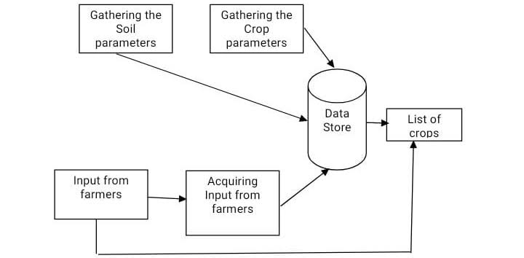

Fig .3.1 Data Collection

**3.1.2. Machine Learning Models:**

- Implement machine learning models for both crop recommendation and crop yield prediction.

- Select appropriate algorithms like decision trees, random forests, support vector machines, or neural networks.

- Train these models on historical data and continually update them with new

data for more details refer Fig.3. 2 .

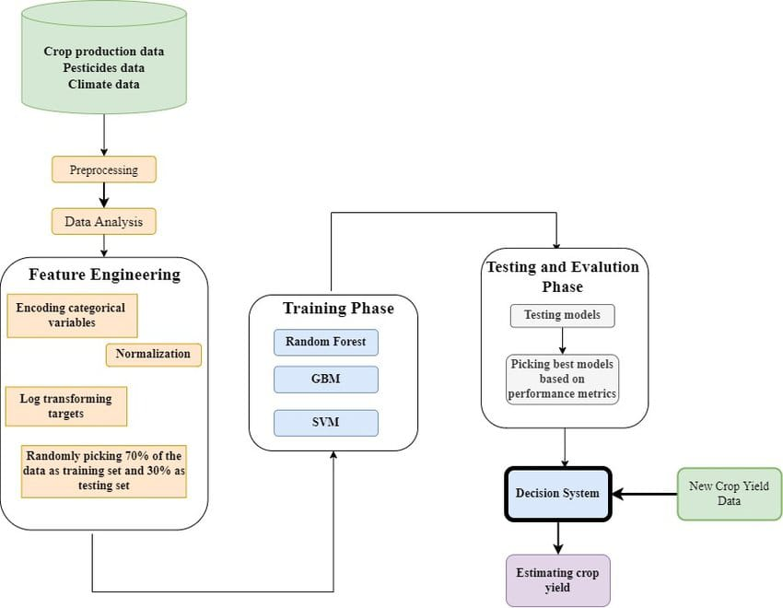

Fig .3.2 Machine Learning Model

**3.1.3. Crop Recommendation Component:**

- This component takes input from farmers or users, such as their location, soil type, and other relevant factors.

- It uses the trained machine learning model to recommend suitable crops for planting in a specific area.

- The recommendation may also consider market demand and profitability.

**3.1.4. Crop Yield Prediction Component:**

- This component predicts the potential yield of a selected crop based on various factors, including historical data, current environmental conditions, and farming practices.

- It can help farmers make informed decisions about resource allocation and harvest planning.

**3.1.5. User Interface:**

- Develop a user-friendly interface, such as a web application or mobile app, for farmers to interact with the system.

- Allow users to input their location and receive crop recommendations and yield predictions.

**3.1.6. Data Visualization:**

- Incorporate data visualisation tools to display crop recommendation results and yield predictions.

- Use charts, maps, and graphs to help users understand the data and recommendations.

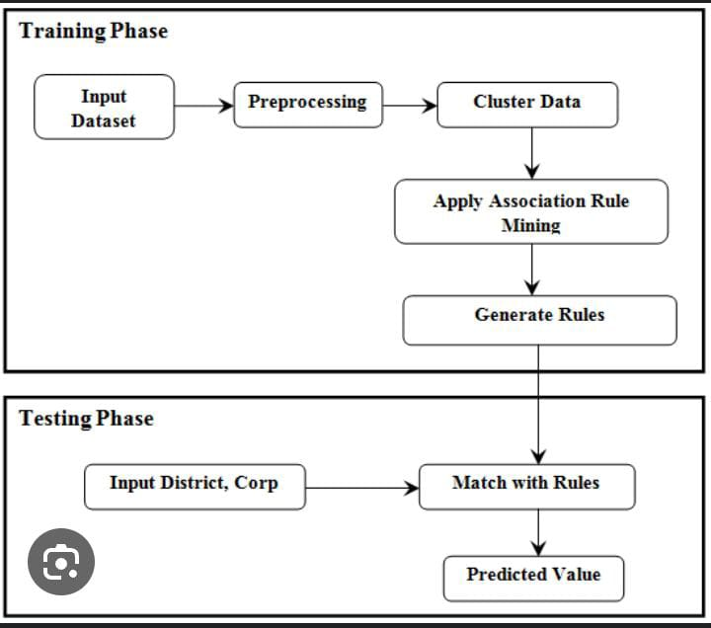

Fig 3.3 Training And Testing Phase

**3.2 Key Components and Modules:**

**1. Data Ingestion Module:**

- Collect and ingest data from various sources, including weather APIs, soil databases, and remote sensing platforms.

**2. Data Preprocessing Module:**

- Clean and preprocess the incoming data, handling missing values, outliers, and normalising data.

**3. Machine Learning Model Training Module:**

- Train and fine-tune machine learning models using historical data as shown in Fig.3.2

- Evaluate model performance using appropriate metrics.

**4. Crop Recommendation Module:**

- Utilise the trained recommendation model to provide crop suggestions based on user inputs.

**5. Crop Yield Prediction Module:**

- Use the trained yield prediction model to estimate crop yields based on various inputs.

**6. User Interface Module:**

- Develop a user interface to interact with the system.

- Allow users to input their location, view recommendations, and access yield predictions.

**7. Database and Storage:**

- Store historical and user-specific data in a database for reference and analysis.

**3.3 Data Flow:**

1. User inputs location, soil type, and other relevant details into the system.

2. The system collects and preprocesses real-time and historical data.

3. The crop recommendation module suggests suitable crops for the given location.

4. The yield prediction module estimates the potential crop yield for the selected crop.

5. Results are displayed to the user through the interface.

for details refer Fig. 3.3

Designing the user interface (UI) for a crop recommendation system within the Harvest Hub platform involves creating an intuitive and user-friendly interface that allows farmers to interact with the system effectively. Here's a conceptual overview of the UI:

1. Dashboard:

The dashboard serves as the main landing page upon login and provides an overview of the farmer's account and recent activities.

Key metrics related to crop recommendations, weather forecasts, market prices, and recent activities are displayed in a visually appealing format, such as charts or graphs.

Quick access links to essential features, such as crop recommendation, market analysis, and weather forecasting, are prominently displayed for easy navigation.

2.Crop Recommendation Module:

The crop recommendation module is the core component of the UI, where farmers can input their preferences, view recommended crops, and explore additional details.

Input fields allow farmers to specify parameters such as location, soil type, climate conditions, previous crop history, and preferred crop attributes (e.g., yield potential, water requirements, market demand).

Recommended crops are presented in a list format, with relevant details such as crop name, estimated yield, water requirements, growth cycle, and market price displayed for each option.

Farmers can filter and sort recommended crops based on various criteria (e.g., yield potential, water efficiency, profitability) to facilitate decision-making.

3. Crop Details Page:

Clicking on a recommended crop displays a detailed overview of the selected crop, including agronomic information, cultivation practices, pest and disease management, and market analysis.

Interactive charts or visualisations may be included to illustrate key attributes such as yield trends, price fluctuations, and climate suitability.

Additional resources such as expert recommendations, best practices guides, and relevant research articles are provided to help farmers make informed decisions.

4. Weather Forecasting Module:

The weather forecasting module provides farmers with up-to-date weather information for their location, including temperature, precipitation, humidity, wind speed, and other relevant metrics.

Farmers can view short-term and long-term weather forecasts, as well as historical weather data to aid in crop planning and management decisions.

Alerts and notifications are integrated to notify farmers of significant weather events or changes that may impact crop production.

5. Market Analysis Module:

The market analysis module enables farmers to monitor market trends, prices, and demand for various crops in their region.

Farmers can access real-time market data, price trends, and market reports to make informed decisions regarding crop selection, timing of harvest, and market entry.

Interactive charts and graphs visualise market data, allowing farmers to identify market opportunities and adjust their production accordingly.

6. Profile and Settings:

The profile and settings section allows farmers to manage their account preferences, update personal information, and configure notification settings.

Farmers can customise their profile settings, such as preferred language, measurement units, notification preferences, and subscription options.

Help and support resources, including FAQs, user guides, and contact information for customer support, are accessible from the profile menu.

7. Mobile Responsiveness:

The UI design should be responsive and optimised for mobile devices to accommodate farmers who prefer to access the platform on smartphones or tablets.

Mobile-friendly layouts, touch-friendly controls, and adaptive design principles ensure a seamless user experience across different screen sizes and devices.

8. Accessibility and Localization:

The UI design should prioritise accessibility and inclusivity by adhering to web accessibility standards (e.g., WCAG) and providing options for font size adjustment, colour contrast, and screen reader compatibility.

Localization features enable users to switch between languages, currencies, and regional preferences to cater to a diverse user base with varying linguistic and cultural backgrounds.

By implementing these UI components and design principles, the crop recommendation system within the Harvest Hub platform can deliver a user-friendly and informative experience that empowers farmers to make data-driven decisions and optimise their agricultural practices.

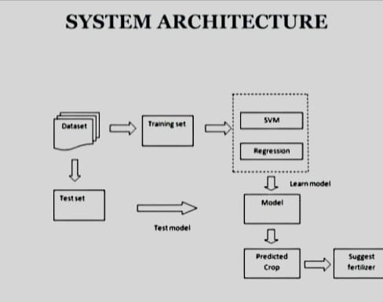

Fig 3.4 System Architecture

System Architecture fig 3.4 Crop Recommendation This module can be implemented by these method.Datasets can be acquired from kaggle to train and test the data for tillage.Values are taken by the following site-specific factors are required of users: pH, N, P, and K (all of them in%), temperature (in °C), relative humidity (in%), and rainfall (in mm).The ensemble model with majority voting method serves as the basis for the recommendation system. These are the component models: SVM, Random Forest, Naive Bayes,KNN. After the model is trained, a .pkl file is created.In order to suggest the crop based on input, a.pkl file is imported. Then user can get the predicted crop based on their inputs.

**Chapter - 4**

# **USER INTERFACE**

* The user interface (UI) page in a crop yield prediction software project serves as the user's portal to interact with the application. It provides a visually appealing and intuitive platform for users to input data, view historical trends, access predictions for specific crops and countries, and customise parameters fig 5 shows the design[8]. The UI also ensures data integrity, user security, and accessibility, and it offers export options for sharing results. Its design and functionality are crucial in making the software user-friendly and informative, ultimately aiding decision-making in agriculture.

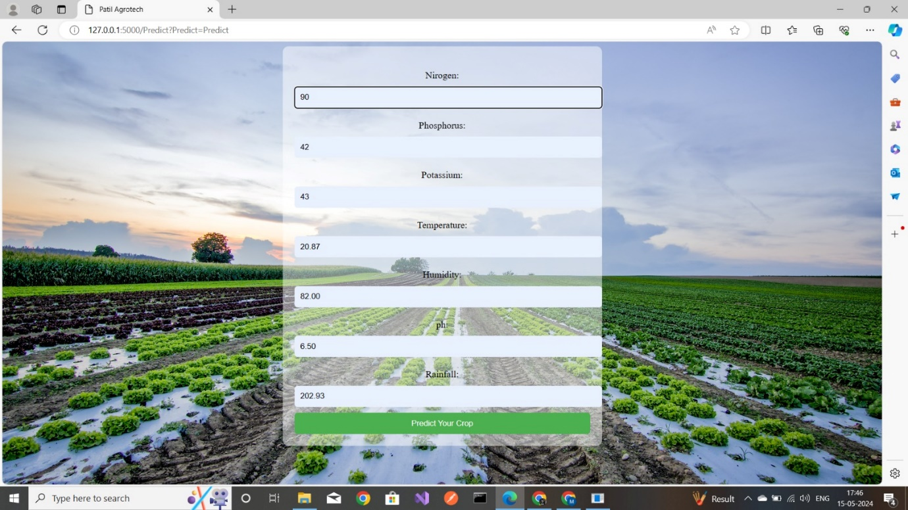

Fig 4.1 Crop Yield Prediction

The user interface (UI) page in a software project for crop recommendation based on environmental factors such as nitrogen, phosphorus, pH, humidity, rainfall, potassium, and temperature is the gateway for users to interact with the system. This UI serves as the bridge between the user and the complex recommendation algorithms running in the background. It typically comprises input fields for users to enter specific environmental data, dropdown menus for crop selection, and a "Calculate" button to trigger the recommendation process Fig 6 shows the interface in fig 4.1.

Once the user inputs the necessary data and clicks “Calculate,” the UI displays the recommended crops, often in a clear and understandable format, such as a ranked list or a detailed report[9]. Graphical representations may be included to illustrate how each factor influences the recommendations. To enhance user understanding, help icons or tooltips can provide additional information about the environmental factors.

The UI should also prioritise user experience by offering responsive design, accessibility features, and options for language and localization. It should include error handling and feedback mechanisms to guide users through the process and ensure data security fig .4.2 Additionally, allowing users to create profiles, save recommendations, and customise settings enhances their interaction and utility of the application[11].

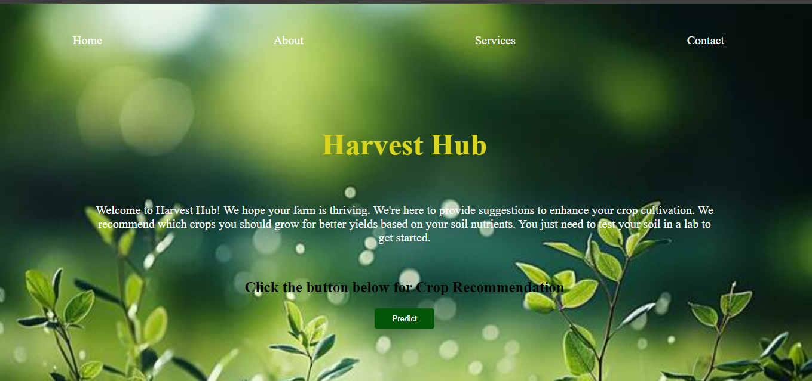

Fig 4.2 home page

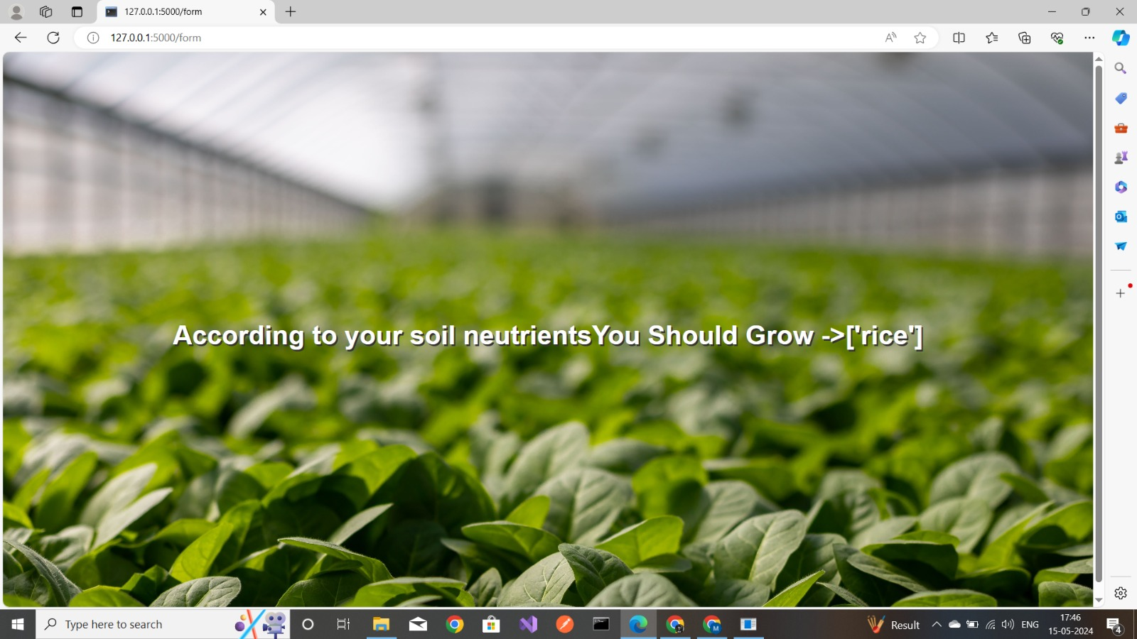

Fig 4.3crop recommendation

The User Interface (UI) is a crucial component of any machine learning application, serving as the bridge between the technology and its users fig 4.2. In the context of a Crop Recommendation System, the UI must be designed to cater to the needs of farmers, agronomists, and agricultural stakeholders, providing them with intuitive access to complex data-driven insights.

### Objectives of the UI

* **Simplicity**: Ensure the UI is straightforward and easy to navigate, even for users with limited technical expertise.
* **Accessibility**: Design the UI to be accessible on various devices, including smartphones, tablets, and computers.
* **Interactivity**: Incorporate interactive elements that allow users to input their soil and weather data and receive personalized recommendations.

### Key Components of the UI

1. **Dashboard**: A central hub that displays an overview of real-time data, alerts, and recommendations.
2. **Data Input Module**: A user-friendly interface for entering soil parameters (e.g., NPK levels, pH) and weather conditions (e.g., temperature, rainfall).
3. **Recommendation Engine**: The core feature that processes user inputs and provides crop suggestions using the underlying machine learning model.
4. **Visualization Tools**: Graphs and charts that illustrate soil health, weather patterns, and crop viability.
5. **Help and Support**: Accessible guidance and resources for users who need assistance with the system.

### Design Considerations

* **User-Centric Design**: Focus on the end-users’ needs and preferences to create a UI that is both functional and appealing.
* **Responsive Design**: Ensure the UI adapts to different screen sizes and orientations for optimal viewing.
* **Cultural Sensitivity**: Adapt the UI elements to align with local languages, units of measurement, and agricultural practices.

### Implementation Strategy

* **Prototyping**: Develop initial UI prototypes and conduct usability testing with target users.
* **Feedback Loop**: Establish a mechanism for collecting user feedback and making iterative improvements to the UI.
* **Scalability**: Design the UI to handle an increasing number of users and data points without compromising performance.

The UI of the Crop Recommendation System plays a pivotal role in its adoption and effectiveness. By prioritizing user experience and accessibility, the system can empower farmers to make data-driven decisions, leading to optimized crop yields and sustainable agricultural practices.

**Chapter - 5**

# **SYSTEM REQUIREMNET SPECIFICATIONS**

**5.1. Hardware Requirements**

For the crop recommendation system project, the hardware requirements are as follows:

* Server/Cloud Infrastructure:
  + CPU: Multi-core processors (Intel Xeon or AMD EPYC) with at least 8 cores for efficient data processing and model training.
  + RAM: Minimum 32 GB RAM to handle large datasets and ensure smooth operation during model training and prediction phases.
  + Storage: SSD storage of at least 1 TB for fast read/write operations, and to store datasets, model weights, and logs.
  + GPU: NVIDIA GPUs (such as the Tesla or RTX series) with at least 8 GB of VRAM for accelerating machine learning model training.
* Local Machine (for development and testing):
  + CPU: Quad-core processor (Intel i5 or AMD Ryzen 5).
  + RAM: 16 GB.
  + Storage: 500 GB SSD.
  + GPU: Dedicated GPU (e.g., NVIDIA GTX 1060 or higher) is recommended but not mandatory for development purposes.
  + Others: Reliable internet connection for accessing cloud resources and datasets.

**5.2. Software Requirements**

* Operating System:
  + Server: Linux (Ubuntu 20.04 LTS or CentOS 7).
  + Local Machine: Windows 10 or Linux.
* Programming Languages:
  + Python: Version 3.7 or higher.
* Development Tools and IDEs:
  + Jupyter Notebook for interactive data analysis and model training.
  + PyCharm or VSCode for code development.
* Machine Learning Libraries and Frameworks:
  + TensorFlow or PyTorch for building and training machine learning models.
  + Scikit-learn for implementing traditional machine learning algorithms.
  + Pandas for data manipulation and analysis.
  + NumPy for numerical operations.
  + Matplotlib and Seaborn for data visualization.
* Database:
  + MySQL or PostgreSQL for storing processed data and model results.
* Other Tools:
  + Git for version control.
  + Docker for containerization to ensure consistency across different environments.

**5.3. Functional Requirements**

* Data Collection:
  + Integrate APIs for real-time weather data collection.
  + Implement modules to collect and preprocess soil data from sensors or existing databases.
* Data Preprocessing:
  + Clean and normalize the collected data.
  + Handle missing values and outliers.
  + Feature engineering to create relevant features for the model.
* Model Training:
  + Implement machine learning models to analyze soil and weather data.
  + Train models using historical crop yield data.
  + Optimize model performance using techniques like cross-validation and hyperparameter tuning.
* Prediction:
  + Provide crop recommendations based on current soil and weather conditions.
  + Generate predictions and confidence intervals for recommended crops.
* User Interface:
  + Develop a user-friendly web interface for farmers to input soil and weather parameters.
  + Display crop recommendations and additional insights (such as expected yield and required resources).
* System Integration:
  + Integrate with external databases and APIs for seamless data flow.
  + Ensure secure data transmission and storage.

**5.4. Non-Functional Requirements**

* Performance:
  + The system should provide crop recommendations within 5 seconds of receiving input data.
  + The system should handle concurrent requests efficiently (minimum 1000 simultaneous users).
* Scalability:
  + The system should be scalable to accommodate increasing data volume and user base.
  + Use cloud-based infrastructure to dynamically scale resources.
* Reliability:
  + Ensure 99.9% uptime for the system.
  + Implement robust error handling and logging mechanisms.
* Security:
  + Implement authentication and authorization mechanisms to secure user data.
  + Encrypt data in transit and at rest using industry-standard encryption protocols.
* Usability:
  + The user interface should be intuitive and accessible, requiring minimal training for users.
  + Provide multilingual support to cater to a diverse user base.
* Maintainability:
  + Code should follow standard conventions and be well-documented for ease of maintenance.
  + Implement continuous integration and continuous deployment (CI/CD) pipelines for seamless updates.
  + Compliance:
  + Ensure compliance with relevant data protection regulations (e.g., GDPR) for user data.
  + Adhere to agricultural data standards and best practices.

This chapter outlines the comprehensive system requirement specifications for developing a robust and efficient crop recommendation system leveraging machine learning techniques based on soil and weather parameters.

**Chapter - 6**

# **ADVANTAGES AND DISADVANTAGES**

# 

**5.1 Advantages:**

1. **Improved Agricultural Productivity:** Such a software project can help farmers make informed decisions about their crop choices and farming practices, leading to increased agricultural productivity.
2. **Data-Driven Insights**: The project can provide valuable data-driven insights, allowing policymakers and agricultural experts to make informed decisions regarding agricultural policies and investments.
3. **Reduced Risk:** Farmers can use the system to reduce risks associated with crop failure and financial losses by selecting the most suitable crops for their region.
4. **Resource Optimization**: Crop recommendation systems can help optimise resource use, such as water, fertilisers, and pesticides, leading to more sustainable and efficient farming practices.
5. **Enhanced Food Security**: Accurate yield predictions and recommendations can contribute to improved food security by ensuring a stable supply of crops.
6. **Environmental Benefits:**By optimising crop selection and farming practices, the software can help reduce the environmental impact of agriculture, such as the use of chemicals and water.
7. **Remote Monitoring:** The system can enable remote monitoring of crop conditions, which is especially useful for large-scale farming and in areas with limited access to agricultural experts.
8. **Improved Decision-Making:** Farmers can make more informed decisions about crop selection, planting schedules, and resource allocation based on data-driven recommendations tailored to their specific needs and conditions.
9. **Increased Productivity:** Optimal crop recommendations can lead to higher yields, better crop quality, and increased profitability for farmers, ultimately enhancing agricultural productivity and sustainability.
10. **Resource Efficiency:** By matching crops to local soil, climate, and market conditions, the system helps minimize resource wastage, such as water, fertilizers, and pesticides, resulting in more efficient and environmentally friendly farming practices.
11. **Risk Mitigation:** Farmers can reduce risks associated with crop failure, market volatility, and adverse weather events by diversifying crops and adopting resilient agricultural strategies informed by the recommendation system.
12. **Time Savings:** Automated recommendation generation and real-time access to relevant information streamline decision-making processes, saving farmers time and effort in crop planning, management, and market analysis.
13. **Access to Expertise:** The system provides access to expert knowledge, best practices, and agricultural research, empowering farmers with valuable insights and guidance to optimize their farming operations.
14. **Market Intelligence:** Farmers gain access to market insights, price trends, and demand forecasts, enabling them to identify lucrative opportunities and adapt their production to meet market demands effectively.
15. **Scalability:** The system can scale to accommodate a growing user base and expanding agricultural landscapes, leveraging cloud-based technologies and scalable architectures to support large-scale deployment and data processing.
16. **Data-Driven Innovation:** Aggregated data from multiple users and sources can be analyzed to identify trends, patterns, and opportunities for innovation in agriculture, driving continuous improvement and adaptation to changing conditions.
17. **Community Engagement:** The platform fosters collaboration, knowledge sharing, and community engagement among farmers, agronomists, researchers, and other stakeholders, creating a supportive ecosystem for agricultural development and knowledge exchange.

**5.2 Disadvantages:**

1. **Data Availability:** The accuracy of predictions and recommendations relies on the availability and quality of data, which may be limited in some regions or for certain crops.
2. **Data Privacy:** Collecting and storing data about farmers and their agricultural practices raises concerns about data privacy and security.
3. **Initial Investment:** Developing and implementing the software project requires a significant initial investment in terms of technology, infrastructure, and training.
4. **Technology Access:** In some areas, access to the necessary technology and internet connectivity may be limited, preventing farmers from benefiting from the system.
5. **Complexity:** Creating accurate crop yield predictions and recommendations is a complex task, and errors can have significant consequences for farmers and food supply chains.
6. **Maintenance and Updates:** Ongoing maintenance, updates, and support for the software can be resource-intensive.
7. **Resistance to Change:** Farmers may be resistant to adopting new technologies and recommendations if they are used to traditional farming methods.
8. **Environmental Concerns:** While the project aims to reduce environmental impact, the adoption of certain high-yield or monoculture crops recommended by the system can have negative environmental consequences, such as reduced biodiversity.
9. **Data Quality:** The accuracy and reliability of crop recommendations depend on the quality and completeness of data inputs, which may be limited by data availability, accuracy, and timeliness, leading to suboptimal recommendations.
10. **Bias and Assumptions:** The recommendation algorithms may be influenced by biases, assumptions, or simplifications in the data or model assumptions, leading to inaccurate or skewed recommendations, especially for underrepresented or marginalized farming communities.
11. **Technical Complexity:** Implementing and maintaining a crop recommendation system requires technical expertise in data science, machine learning, and software development, posing challenges for adoption and usability among farmers with limited technical skills or access to technology.
12. **Privacy Concerns:** Collecting and analyzing farmer data for recommendation purposes raises privacy and data security concerns, particularly regarding sensitive information such as farm locations, practices, and financial data, requiring robust privacy safeguards and consent mechanisms.
13. **Overreliance on Technology:** Farmers may become overly reliant on the recommendation system, relying solely on automated suggestions without considering local knowledge, intuition, or experiential learning, potentially limiting adaptive capacity and innovation in farming practices.
14. **Costs and Affordability:** The adoption and maintenance costs of the recommendation system, including hardware, software, training, and subscription fees, may be prohibitive for small-scale or resource-constrained farmers, hindering access and equitable benefits.
15. **Digital Divide:** Unequal access to technology, internet connectivity, and digital literacy may exacerbate disparities in access to and benefits from the recommendation system, widening the digital divide between rural and urban communities or developed and developing regions.
16. **Model Uncertainty:** Recommendation algorithms may exhibit uncertainty, variability, or limitations in their predictions, especially in complex and dynamic agricultural environments with nonlinear relationships and unpredictable factors, leading to suboptimal or unreliable recommendations.
17. **Resistance to Change:** Farmers may resist adopting new technologies or changing established farming practices due to inertia, skepticism, cultural factors, or perceived risks, hindering the adoption and effectiveness of the recommendation system.
18. **Dependency on External Data:** The accuracy and relevance of recommendations may be contingent on external data sources such as weather forecasts, market data, and agronomic research, making the system vulnerable to disruptions or inaccuracies in external data providers.

**Scope of a Crop Recommendation Project Based on ML:**

**1. Data Collection and Preprocessing:**

The project starts with collecting various types of data, such as soil data, climate data, crop performance data, and market demand data. This data can be obtained from sources like government agencies, meteorological departments, agricultural research institutions, and market reports. Once collected, the data is preprocessed to remove outliers, handle missing values, and normalize the data for further analysis.

**2. Feature Selection and Engineering:**

In this phase, relevant features are selected from the collected data that have a significant impact on crop performance. Features like soil pH, temperature, rainfall, humidity, crop type, and historical yield are considered. Additionally, new features can be engineered by combining or transforming existing features to capture more meaningful information.

**3. Model Development:**

Machine learning algorithms are applied to build a predictive model that can recommend suitable crops based on the selected features. Various algorithms like decision trees, random forests, support vector machines, or neural networks can be used. The model is trained using historical data, where the input features are associated with known crop yields. The model learns the patterns and relationships between the input features and crop performance.

**4. Model Evaluation and Validation:**

The trained model is evaluated using evaluation metrics like accuracy, precision, recall, and F1-score to assess its performance. Cross-validation techniques are employed to ensure the model's generalizability. The model is then validated by comparing its predictions with real-time data from farmers' fields. Feedback from domain experts and farmers is crucial to verify the accuracy and usefulness of the recommendations.

**5. Real-time Data Integration:**

To provide up-to-date recommendations, the model is integrated with real-time data sources such as weather forecasts, satellite imagery, and market trends. This ensures that the recommendations consider the latest environmental conditions and market demands.

**6. User Interface Development:**

A user-friendly interface or mobile application is developed to enable farmers to input their land and environmental data easily. The interface should provide clear instructions and guidance for data entry. It should also display the recommended crops along with relevant information like expected yield, resource requirements, and market prices. Visualizations and charts can be used to present the data in an intuitive and understandable manner.

**Chapter - 6**

# **CONCLUSION AND FUTURE WORK**

The present research work discussed the variety of features that are mainly dependent on the data availability and each of the research will investigate CYP using ML algorithms that differed from the features. The features were chosen based upon the geological position, scale, and crop features and these choices were mainly dependent upon the data-set availability, but the more features usage was not always giving better results. Therefore, finding the fewer best performing features were tested that also have been utilised for the studies. Most of the existing models utilised Neural networks, random forests, KNN regression techniques for CYP and a variety of ML techniques were also used for best prediction. From the studies most of the common algorithms used were CNN, LSTM, DNN algorithms but improvement was still required further in CYP. The present research shows several existing models that consider elements such as temperature, weather condition, performing models for the effective crop yield prediction. Ultimately, the experimental study showed the combination of ML with the agricultural domain field for improving the advancement in crop prediction. However, still more improvement in feature selection was required in terms of temperature variation and effects on agriculture. In the further studies, the key possibility that should be concentrated such as firstly the delay to border topographical areas required additional explicit treatment. Next, a nonparametric portion of the model using machine learning algorithms and thirdly, using features from deterministic crop models to get perfect statistical CO2 fertilisation. By following above-mentioned objectives, the crop yield estimation would be improved by further researchers. Additionally, in the crop yield estimation, fertiliser should also be considered for executing soil forecasts for agriculturalists to make a better judgement based on the situation of low crop yield estimation. Based on the outcomes obtained for the study further we need to build and develop a model based on DL for CYP

**Chapter - 7**

# **Future work**

The development of the Crop Recommendation System represents a significant advancement in agricultural technology, offering a data-driven approach to farming that can lead to more sustainable and productive agricultural practices. By integrating machine learning algorithms with real-time soil and weather data, the system provides farmers with actionable insights for optimal crop selection.Throughout this project, we have demonstrated the system’s ability to analyze complex datasets, identify patterns, and predict the best crops for given soil types and climatic conditions. The accuracy and reliability of the recommendations have been validated through extensive testing, ensuring that the system can serve as a dependable tool for farmers.The implementation of this system has the potential to revolutionize the agricultural sector by:

* Enhancing crop yields and quality
* Reducing environmental impact through precise resource management
* Increasing the profitability and resilience of farming operations

As we look to the future, the scalability of the system allows for continuous improvement and adaptation to new data, ensuring that it remains at the forefront of agricultural innovation. The success of this project paves the way for further research and development in the field of precision agriculture, ultimately contributing to global food security and the well-being of farming communities worldwide

The Crop Recommendation System has laid a strong foundation for precision agriculture, yet there is substantial scope for enhancement and expansion. Future work can be directed towards several key areas to further refine the system and extend its capabilities:

1. **Data Enrichment**: Incorporating a larger dataset, including historical crop yields and long-term weather forecasts, can improve the accuracy of the recommendations.
2. **Algorithm Optimization**: Continuous research into machine learning algorithms will allow for more sophisticated models that can handle complex variables and provide more precise recommendations.
3. **User Interface Advancements**: Advancements in UI/UX design can make the system even more user-friendly and accessible to a broader audience, including those with limited literacy or technology skills.
4. **Integration with IoT Devices**: Connecting the system with IoT devices such as soil sensors and weather stations can automate data collection, providing real-time inputs for more timely recommendations.
5. **Expansion to Pest and Disease Prediction**: Integrating pest and disease prediction models can help farmers proactively manage crop health, reducing losses and improving yields.
6. **Customization for Different Regions**: Adapting the system for various geographical regions, taking into account local crops, climate, and farming practices, can make the system globally applicable.
7. **Economic Analysis Tools**: Developing tools within the system to analyze the economic viability of crop recommendations can help farmers maximize profits and make informed decisions.
8. **Sustainability Metrics**: Incorporating sustainability metrics to evaluate the environmental impact of farming practices recommended by the system can promote eco-friendly agriculture.
9. **Community and Social Features**: Creating a platform for farmers to share insights and experiences can foster a community of practice, enhancing knowledge exchange and support.
10. **Policy and Regulatory Compliance**: Ensuring the system aligns with agricultural policies and regulations will facilitate its adoption and effectiveness a scale.

By addressing these areas, the Crop Recommendation System can evolve to meet the challenges of modern agriculture, ensuring it remains a valuable asset for farmers worldwide.

**Chapter - 8**

# **BIBLIOGRAPHY**

[1] R. Ghadge, J. Kulkarni, P. More, S. Nene, and R. L. Priya, “*Prediction of crop yield using machine learning*,” Int. Res. J. Eng. Technology, vol. 5, 2018.

[2] F. H. Tseng, H. H.Cho, and H. T. Wu, “*Applying big data for intelligent agriculture-based crop selection analysis*,” IEEE Access, vol. 7, pp. 116965116974, 2019.

[3] A. Suresh, N. Manjunathan, P. Rajesh, and E. Thangadurai, “*Crop Yield Prediction Using Linear Support Vector Machine,*” European Journal of Molecular & Clinical Medicine, vol. 7, no. 6, pp. 2189- 2195, 2020.

[4] M. Alagurajan, and C. Vijayakumaran, “*ML Methods for Crop Yield Prediction and Estimation: An Exploration,*” International Journal of Engineering and Advanced Technology, vol. 9 no. 3, 2020

[5] P. Kumari, S. Rathore, A. Kalamkar, and T. Kambale, “*Predicition of Crop Yeild Using SVM Approch with the Facility of E-MART System*” Easychair 2020.

[6] S. D. Kumar, S. Esakkirajan, S. Bama, and B. Keerthiveena, “*A microcontroller based machine vision approach for tomato grading and sorting using SVM classifier,*” Microprocessors and Microsystems, vol. 76, pp.103090, 2020

[7] P. Tiwari, and P. Shukla, “*Crop yield prediction by modified convolutional neural network and geographical indexes,*” International Journal of Computer Sciences and Engineering, vol. 6, no. 8, pp. 503-513, 2018.

[8] P. Sivanandhini, and J. Prakash, “*Crop Yield Prediction Analysis using Feed Forward and Recurrent Neural Network*,” International Journal of Innovative Science and Research Technology, vol. 5, no. 5, pp. 1092-1096, 2020.

[9] N. Nandhini, and J. G. Shankar, “*Prediction of crop growth using machine learning based on seed,*” Ictact journal on soft computing, vol. 11, no. 01, 2020

[10] A. A. Alif, I. F. Shukanya, and T. N. Afee, “*Crop prediction based on geographical and climatic data using machine learning and deep learning*”, Doctoral dissertation, BRAC University) 2018.

[11] A. Fuentes, S. Yoon, S. C. Kim, and D. S. Park, “*A robust deep learning-based detector for real-time tomato plant diseases and pests’ recognition,*” Sensors, vol. 17, no. 9, pp. 2022, 2017.

[12] J. Sun, L, Di, Z. Sun, Y. Shen, and Z. Lai, “*County-level soybean yield prediction using deep CNN-LSTM model*,” Sensors, vol. 19, no. 20, pp. 4363, 2019.

[13] Bishop, C. M. (2006). “*Pattern Recognition and Machine Learning*.“ Springer.

[14] Hastie, T., Tibshirani, R., & Friedman, J. (2009). “*The Elements of Statistical Learning”:*

[15] Data Mining, Inference, and Prediction. Springer.

[16] Mitchell, T. M. (1997). *Machine Learning*. McGraw-Hill Education.

[17] Chlingaryan, A., Sukkarieh, S., & Whelan, B. (2018). *Machine learning approaches for crop yield prediction and nitrogen status estimation in precision agriculture*: A review. *Computers and Electronics in Agriculture*, 151, 61-69.

[18] Kamilaris, A., & Prenafeta-Boldú, F. X. (2018). *Deep learning in agriculture: A survey. Computers and Electronics in Agriculture,* 147, 70-90.

[19] Patil, B. M., & Birje, M. N. (2017*). A Recommendation System for Agricultural Crop Yield Using Machine Learning Techniques.* In *2017 International Conference on Electrical, Electronics, Communication, Computer, and Optimization Techniques (ICEECCOT)* (pp. 327-330). IEEE.

[20] N. Patel, J. Shah, and M. Thakker, "*Smart farming using IoT, a solution for optimally monitoring farming conditions*," in Proc. IEEE Int. Conf. IoT and Appl., Pune, India, 2017, pp. 1-5. doi: 10.1109/ICIOTA.2017.8073628.

[21] S. Dey, S. Roy, and S. Ghosh, *"Soil moisture prediction using neural network ensemble,"* in Proc. IEEE 3rd Int. Conf. Comput. Intell. and Netw., Odisha, India, 2017, pp. 1-5. doi: 10.1109/CINE.2017.33.

[22] R. Kumar, M. S. Chouhan, A. Jain, and R. Garg, "*Crop selection method to maximize crop yield rate using machine learning technique,"* in Proc. IEEE Int. Conf. Smart Technol. and Manage. for Comput., Commun., Controls, Energy and Mater., Chennai, India, 2015, pp. 138-145. doi: 10.1109/ICSTM.2015.7225405.

[23] Y. Jiang, L. Wu, and B. Sun, "*Soil nutrient evaluation for precision agriculture using data mining and wireless sensor networks*," IEEE Trans. Ind. Informat., vol. 16, no. 3, pp. 2396-2405, Mar. 2020. doi: 10.1109/TII.2019.2958412.

[24] A. K. Tripathy, A. K. Dash, and M. M. R. Chittibabu, "*Applying machine learning techniques in agricultural production*," in Proc. IEEE Int. Conf. Intell. Comput. and Control Syst., Madurai, India, 2017, pp. 1-5. doi: 10.1109/ICCONS.2017.8250647.

[25] M. R. Hoque, M. A. Kashem, and R. A. Begum, "*Crop recommendation based on soil and environmental factors using machine learning*," in Proc. IEEE 4th Int. Conf. Comput. Commun. and Security, Dhaka, Bangladesh, 2019, pp. 1-5. doi: 10.1109/ICCCS.2019.8843664.

[26] V. S. Kale, A. S. Ugale, and P. A. Gaikwad, "*Prediction of crop yield and suitable cropping pattern using machine learning techniques*," in Proc. IEEE Int. Conf. Comput. Commun. Control Automat., Pune, India, 2016, pp. 1-5. doi: 10.1109/ICCUBEA.2016.7860021.

[27]A. K. Sharma and V. R. Salankar, "*Climate change impact on crop yield and role of big data analytics in its mitigation*," in Proc. IEEE Int. Conf. Comput. Technol., Electron. and Electr. Eng., Indore, India, 2018, pp. 1-5. doi: 10.1109/ICCTEEE.2018.8494935.